# W2D2 Homework

*Flores, Jerica N.*

# Question 1

Table emp, order by ename increasing，which one or more are correct?

A.select ename , salary from emp   order by ename asc

B.select ename , salary from emp   order by ename desc

C.select ename , salary from emp   order by salary asc

D.select ename , salary from emp   order by ename  ;

# Question 2

Table EMPLOYEES

EMPLOYEE_ID   NUMBER   Primary Key  FIRST_NAME     VARCHAR2(25)  LAST_NAME      VARCHAR2(25)

Which one insert one record to the table correctly?

A. INSERT INTO employees(employee_id) VALUES (1000);

B. INSERT INTO employees (first_name,last_name) VALUES (‘John’,’Smith’);

 C. INSERT INTO employees VALUES(1000,’John’,’NULL’);

D. INSERT INTO employees VALUES (‘1000’,’John’);

# Question 3

SELECT name, rank, serialNo FROM employee.

Which one to get the value of first column of rs?

A. rs.getString(0);

B. rs.getString("name");

C. rs.getString(1);

D. rs.getString(“ename”);

# Question4

At first in database, create a table Employee, id is primary key.

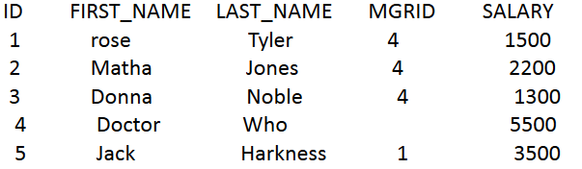

1. Create a table, and insert a record to the table, and print out all the data in the table

(6 Alex Lee 1 4500)

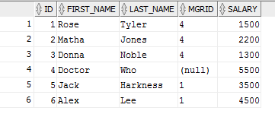

1. Modify the last_name to “Tate” whose last_name is “Jones” , and save it to database. And print out all the data in the table.

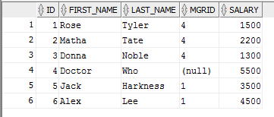

# Question 5

Why we use Class.forName?

Class.forName is used to load the driver class. It causes the class to be dynamically loaded at runtime.

# Question 6

What’s the difference between Statement and PreparedStatement?

Statement is used for the general purpose access to the database and is not flexible for supplying arguments dynamically while PreparedStatement is used when you want to use the SQL statements many times and it accepts parameters, it is flexible for supplying arguments dynamically.

# Question 7

How to close the resultset, statement and connection after we finished the database operation? Write the codes.

resultSet.close()

statement.close()

connection.close()